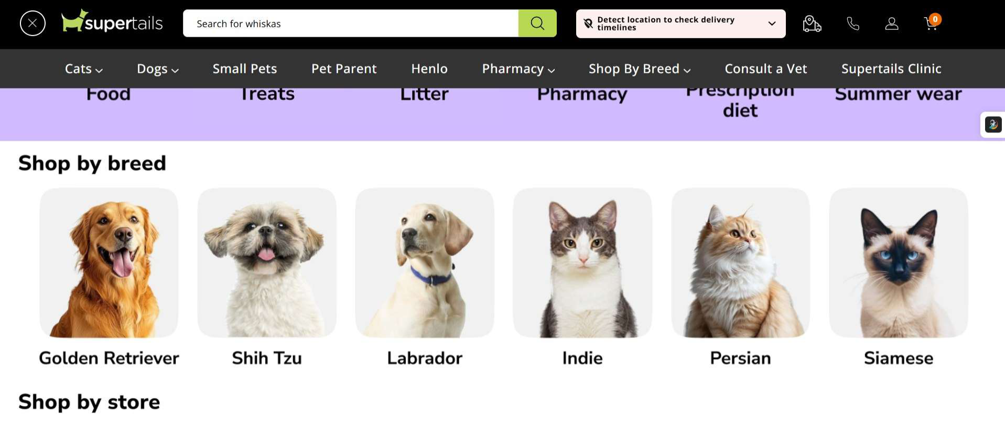

1. Introduction

In this report, the interface of Supertails, the top technology enabled pet care provider in India (whose author has been using personally and has discovered interface design flaws), is being analyzed. The analysis of the interface will focus only on the issues related to learnability, usability, consistency, and use of metaphors. This report will not cover engineering or business issues. The analysis will include the evaluation of the interface based on usability criteria using actual screenshots captured during the navigation through the site, and based on Shneiderman's Eight Golden Rules of Interface Design.

2. Website Analysis: Supertails (supertails.com)

Supertails is an online pet care platform that provides pets' food, pharmacy, accessories, and veterinary consultations with delivery throughout the country. Although the platform covers a great number of pet related categories, there are several common interface design issues, observed during the navigation through the site, such as layout collision for the sticky header, overlapping promotional information, and conflicting location prompters. Screenshot below illustrates the particular flaws captured directly during the navigation through the site.

2.1 Observed Flaws (with Screenshots)

Fig. 1 – Header and Category Tabs Colliding: Sticky "Detect location to check delivery timelines" banner overlaps with category tabs (Food, Treats, Litter, Pharmacy, Prescription diet, Summer wear) directly below it. The text in both layers is overlapping; therefore, part of it is not readable. This is a clear layout/z-index rendering error and not a purposeful design decision.
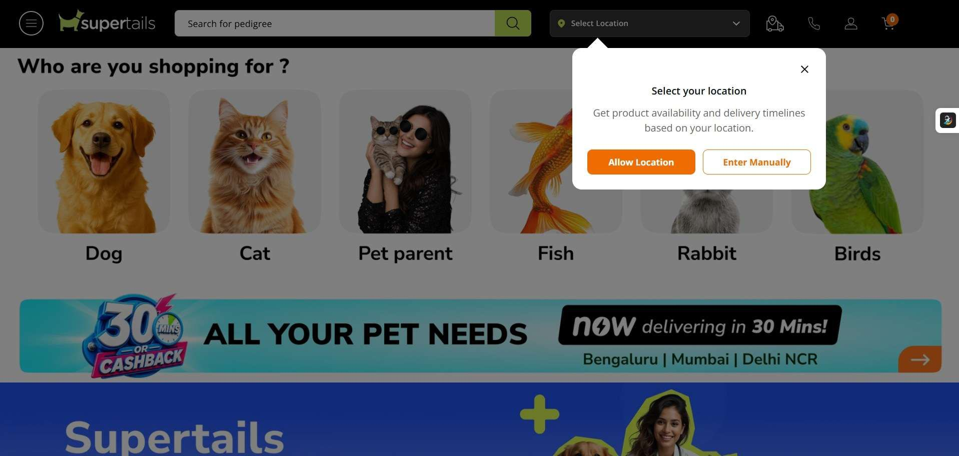
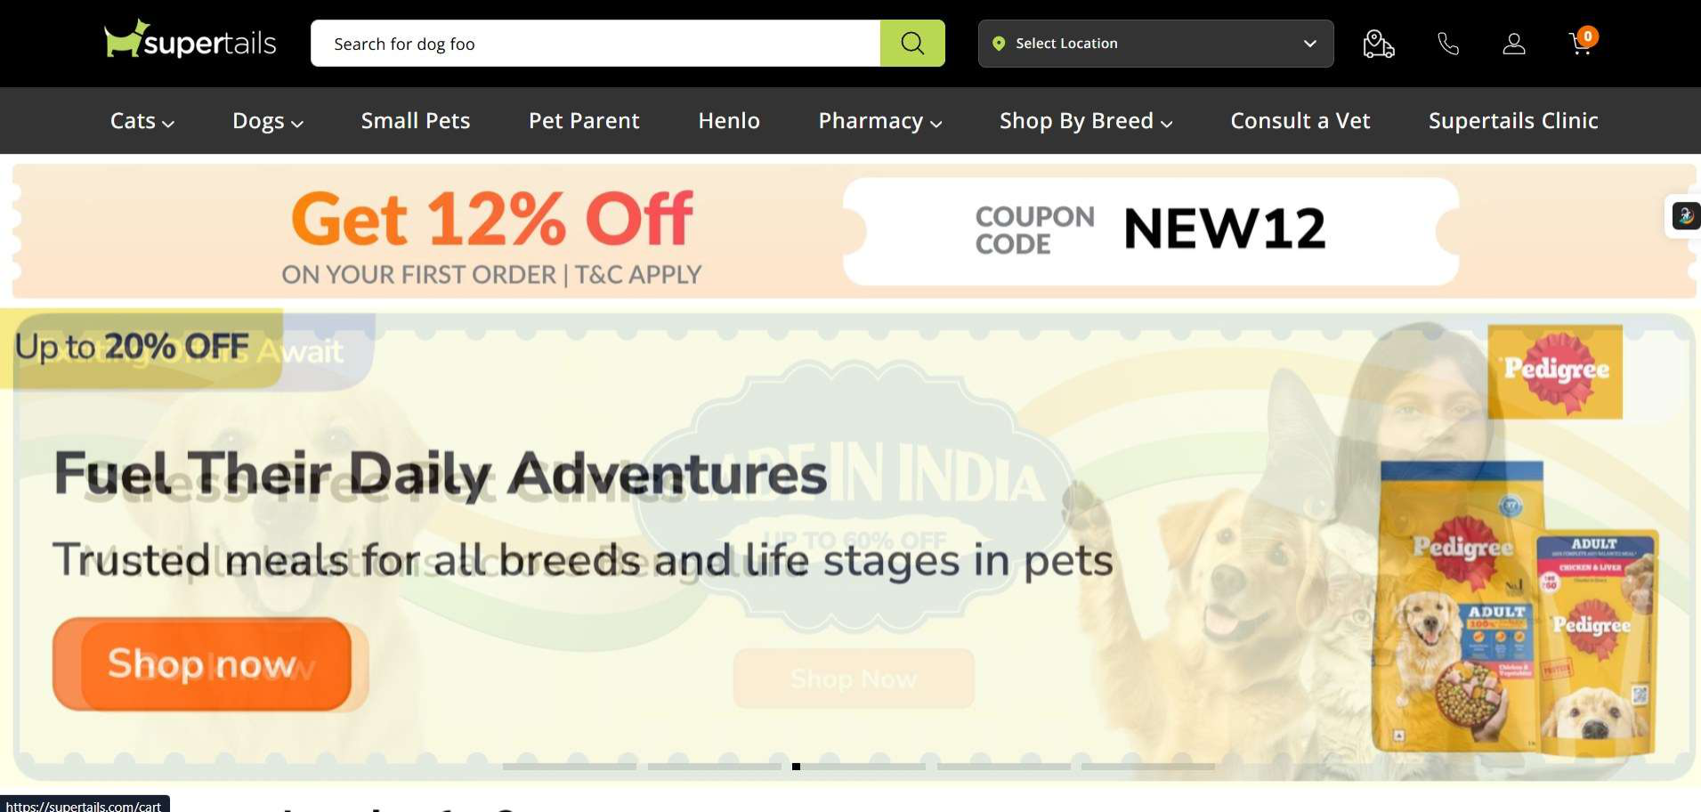
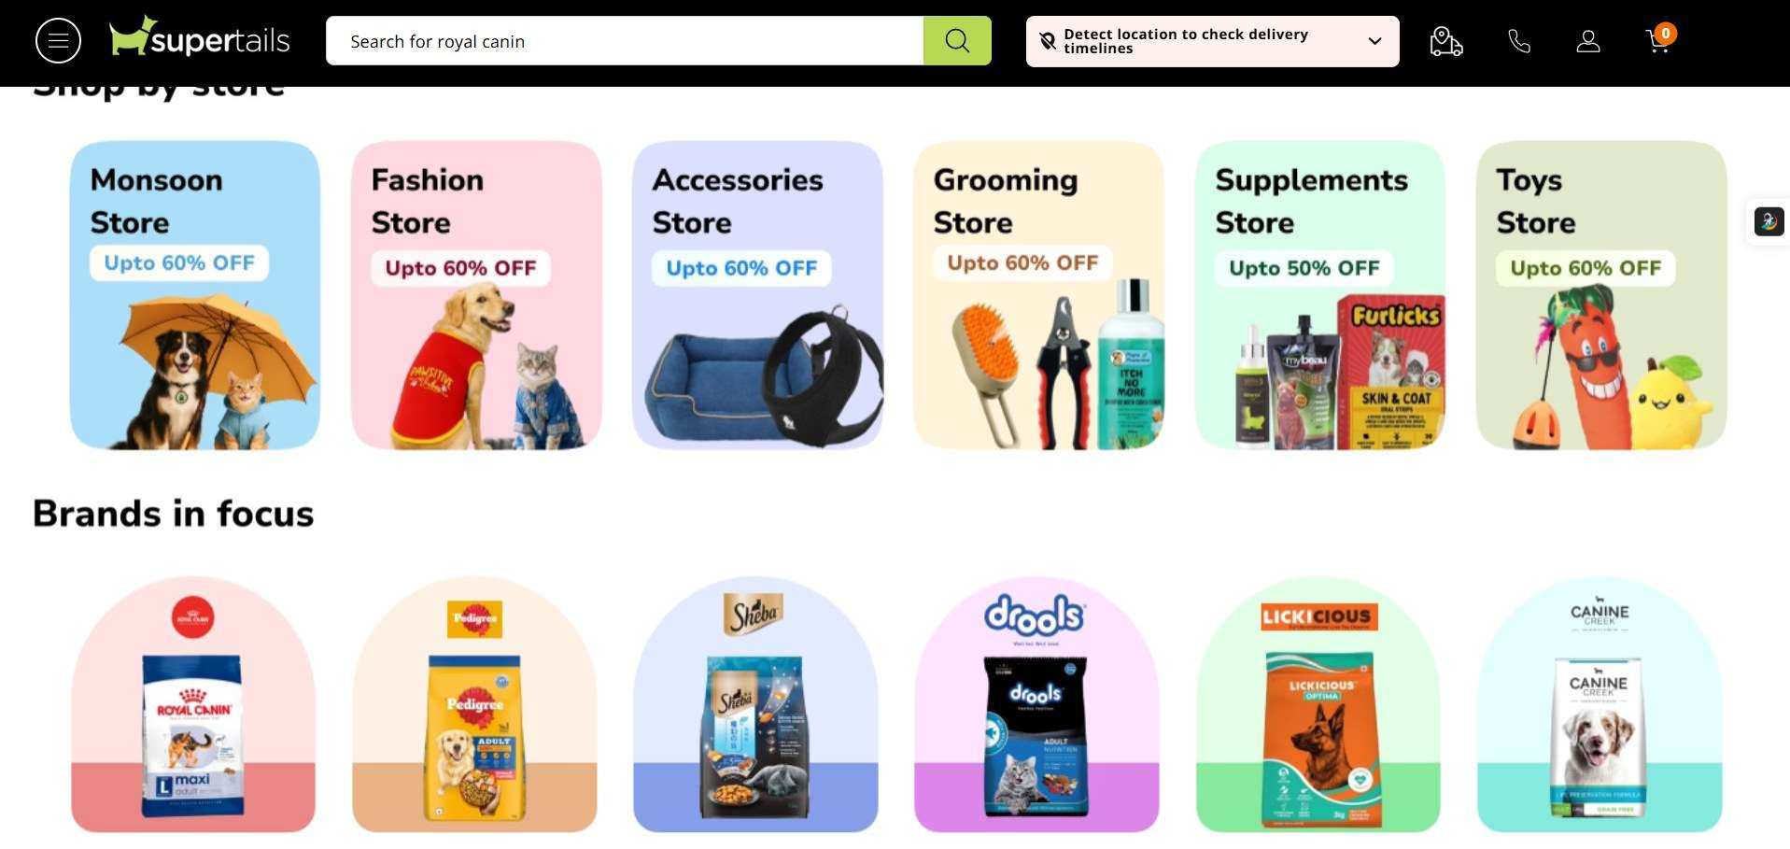

Fig. 2 – Same Layout Collision Recurring at the Store Page: Identical header and category tabs collision appears again at the next page (Shop by Store and Brands in focus).

Fig. 3 – Overlapping Slides of Hero Carousel: The main page of the site shows overlapping slides of hero banner carousel: "Fuel Their Daily Adventures" Pedigree ad overlapped with "Made In India" and "...pet clinics in Bengaluru" faded text of another slide.

Fig. 4 – Multiple Overlapping Location Request Interfaces: A "Select your location" modal appears immediately above the "Who are you shopping for?" category selector — one of the primary onboarding interfaces on the site — without giving users a chance to select anything in it first. This comes on top of a "Detect location" prompt in the header, which means that the site is asking for a user’s location via two interfaces simultaneously.
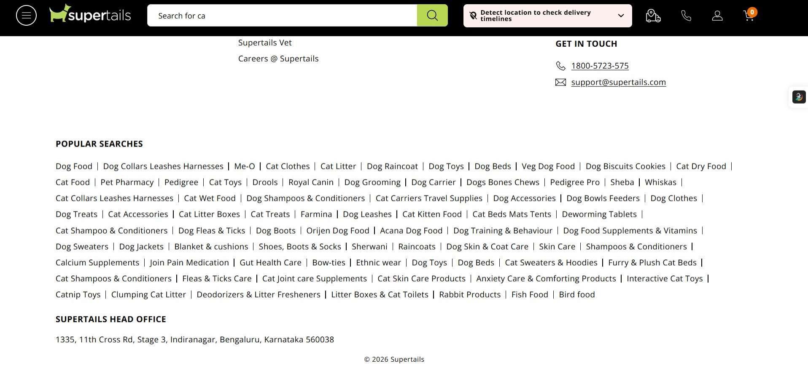
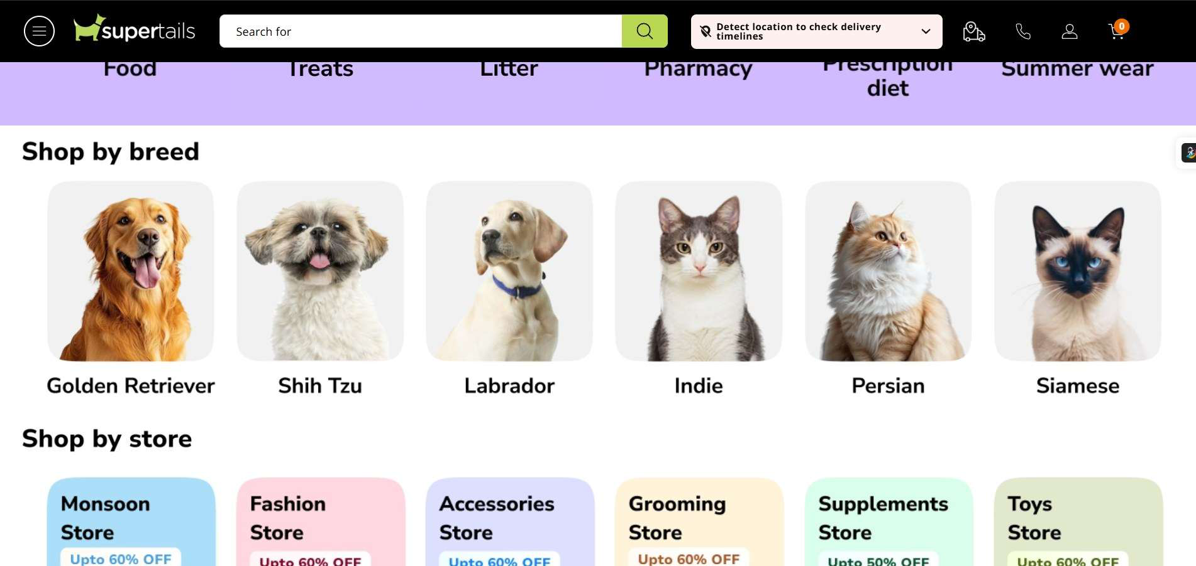

Fig. 5 – Overlapping Text Issue Occurs Again on "Shop by Breed" Page: Here we see an example of overlapping between text in the header and text in the category bar, confirming that the issue is not limited to just one page but occurs elsewhere as well. Text on the "Detect location" banner overlaps the "Prescription diet" and "Summer wear" tabs partially.

Fig. 6 – "Popular Searches" Links Collection in Unstructured Footers: The footer consists of 80+ links arranged in dense paragraphs without any separation, categorisation, or structure. It covers all kinds of topics related to pet care, including "Dog food" and "Bird food." This seems like an attempt to do search engine optimisation instead of providing useful information for users.

2.2 Core Parameters (Summary)

Parameter

Learnability

Usability

Consistency
Observation / Problem

A first-time visitor is met with a rotating placeholder search bar showing unrelated example terms ("whiskas", "royal canin", "pedigree") rather than guidance, plus a location modal that interrupts the core "who are you shopping for" onboarding step before it can be used.

The recurring header/tab-bar collision (Figs. 1, 2, 5) makes navigation labels partly unreadable on multiple pages, forcing users to guess at category names or scroll past the broken region to find working links.

Discount badges across the "Shop by Store" tiles use inconsistent percentages and colour treatments ("Upto 60% OFF" vs "Upto 50% OFF") with no clear pattern, and the
Golden Rule Violated

Reduce short-term memory load

Prevent errors

Strive for consistency
Parameter

Use of Metaphors
Observation / Problem

location prompt appears in three different forms across the site (header banner, dropdown, and modal).

Category tiles (Dog, Cat, Fish, Rabbit, Birds) use clear, recognisable photography as metaphors for each shopping path, which works well — but this strength is undermined by the layout bugs overlapping the surrounding navigation elements.
Golden Rule Violated

Reduce short-term memory load

2.3 Supporting Observations

• Feedback and System Status: There is no clear indicator that one of the sliding carousel ads in Fig. 3 is currently selected.
• Error Prevention and Recovery: Offering two different location request interfaces at the same time (the banner and the modal) increases the risk of confusing users. They may ignore one of them unintentionally, leaving another request unanswered and causing confusion regarding delivery terms.
• Aesthetics and Minimalism: The footer has a messy "Popular Searches" section (Figure 6), and the hero banner overlay is another element adding clutter to the homepage (Figure 3).
• Visual Hierarchy: In Figure 4, the location modal is given more visual weight than the category picker where the location modal is displayed on top of; however, the latter is the more important element and represents the most essential step for a new visitor.
3. Conclusion

The Supertails website presents an extensive, professionally photographed product catalog and understandable categories, however, this is spoiled by the constant design/functional clash between the sticky header and the category tabs, observed throughout multiple webpages of the website. Alongside with the overlap of promotion carousels and location prompts, the website leaves the user with a messy first impression. Application of Shneiderman's golden rules, specifically, consistency, prevention of errors, and proper visual hierarchy of onboarding elements, will greatly help to address the problem.

